CLIMATE TALK
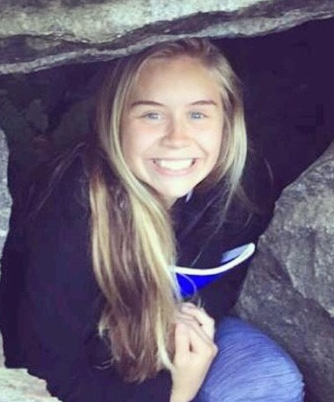
Our Climate – A Call to Action
EmmaMarie Hammond
Ashland

My recent attendance at the Wisconsin Citizens' Climate Lobby Convention made a point very clear: There is evidence of climate change. It is not simply a matter of believing or not believing. At the end of the day, issues revolving around climate become issues of politics and economics. And then the web continues with issues in social and environmental justice.
I spent my last semester shadowing the Chequamegon Citizens' Climate Lobby chapter, researching, immersing, educating and connecting myself to local knowledge, political issues and environmental issues. It was enough for me, as a member of the next generation, to have a mix of emotions. One step forward, two steps back. We all strive to live the best lives, trying to achieve societal standards and the unsaid rules of acceptance. As a simple human being, I experience these demands coming from numerous directions.
My generation needs to respond to a call for action; beyond the hashtags and Facebook posts. We need real and proactive activism and need to familiarize ourselves with more than just news headlines out of context and statements on a screen. Action can still be purposeful before disaster strikes, though one could argue that such has already occurred.
In a time where things get done only as a matter of convenience, I encourage my fellow peers to go beyond their comfort zones, and truly contemplate their values and hopes for the future. I applaud Citizens' Climate Lobby for being an extremely well-organized organization and connecting polarized stances to find common ground. It does not just exist as an outlet of participation for the experienced, but for those on all levels with climate concerns. It is an outlet of education, fostering proactive relationships out of respect and intent.
It’s enlightening to look around the room at our local Citizens’ Climate Lobby meetings; many of the individuals there would identify as retired or “getting older.” But the efforts and activism of our community are hardly retired or sitting back and relaxing. If people didn’t think climate change was an issue, I certainly don’t think the retired and already employed would be sitting at meetings and have an eagerness to spend their evenings conversing with politicians. I am inspired by the individuals and the communities that have taken their concerns and turned them into opportunities. I can only hope that those at the forefront of these efforts take time to help bring up the next generation, by continuing to inspire and educate with the respect that Citizens’ Climate Lobby so much advocates for.
As a student, I struggle with the process of recruiting other students and encouraging them to put their interests into action. My generation is faced with big questions: How do we maintain a high standard of living without fossil fuels? What do we do with the Pacific Trash Patch? How do we respond to permafrost melting? Will we be able to find a solution that will benefit all classes, rich and poor? How do we get people to listen?
These questions can present themselves at very desperate times. Unfortunately, students are not always able to answer these questions inside a classroom. I am a firm believer that education exists beyond the classrooms, existing in the knowledge of our communities, landscapes and experiences. I urge those who wish to take up the challenge/opportunity that climate change has presented to join the efforts of Citizens’ Climate Lobby and become informed, socially and politically, active global citizen.

EmmaMarie Hammond is going on her third year as a student at Northland College, studying water science and environmental humanities. She will be attending the international Citizens’ Climate Lobby Conference in Washington, D.C., in June.

